**4.5 I can archive the outcomes of collaborative working.**

Version control allows for the automatic saving/ backup of a version of a file. This means, should something go wrong with a subsequent save then the earlier version will be available, saving the need to re-create it.

Version control is also the process of allowing one person to have read-write authority over a file, whilst others have right to read-only. This saves updates to one file causing information in another to be overwritten.

There are a large number of pieces of software that facilitate version control, typically by creating copies of documents and saving them. The Microsoft Office suite is one example, saving versions of files after certain periods of time. There have been a number of times I have forgotten to save a document and later been provided with an automatically saved backup copy, which has been very convenient.

Git and TortoiseSVN are other free open/source version distribution programs.

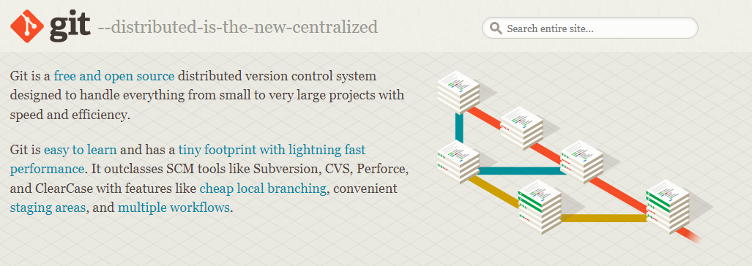

*Screenshot taken from* [*https://git-scm.com/*](https://git-scm.com/)

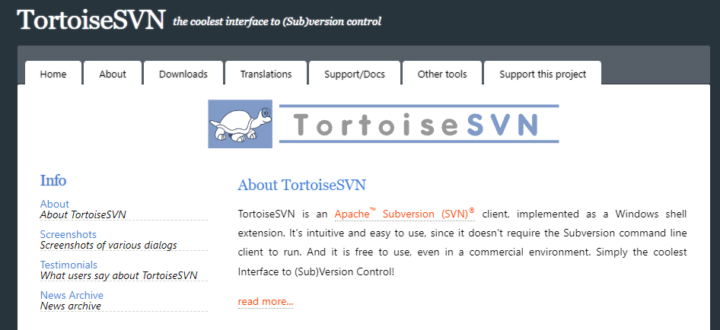

*Screenshot taken from https://tortoisesvn.net/*